Icas as Alarm System ”SMARTLOCK”.

Professional Alarm system for protection of personal items such as ”Bikes,Outboard engines,Garden Tools,barbecues,sateliteantennas etc.. Smartlock covers most of the need for protection against teft in a private home.

- ”Intelligent” Uses a 7m steelwire having elctronic protection against sabotage.
- Protected against tampering
- Can be connected to a sentral intruder system
- Easy installation and use
- Weather protected!

Technical spec.:
Default user code: 0000
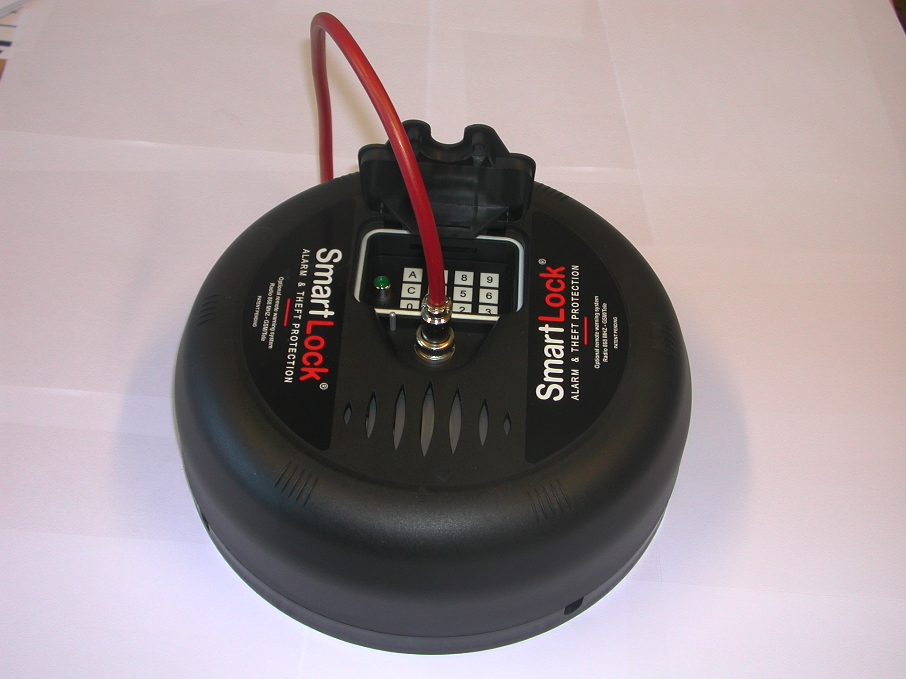
Tamper protected 3times wrong code! . Must be Reset thereafter.
Delays when disconnect: 20 sec.
Battery operation when activated: Approx.9months without Alarms.
Ative Sounder time when in Alarm: 2 min. Then automatic canselled
Sounder : 90db in 1m radius.
Output to external equipment: Open collector
Backup battery: 12VDC/1,2 Ah.
Re-charging: 12-24 hours.
Lenght of Alarm wire: 7m, can be extended to10 m.
Wire: Steel armouring of multiple cable,
Covered in UV protected plastic hose.
Powersupply/Battery charger: 12VDC, 500mA/6VA.
Weight: 2,6 kg.
Size: d=24,5cm , h=8,5 cm

